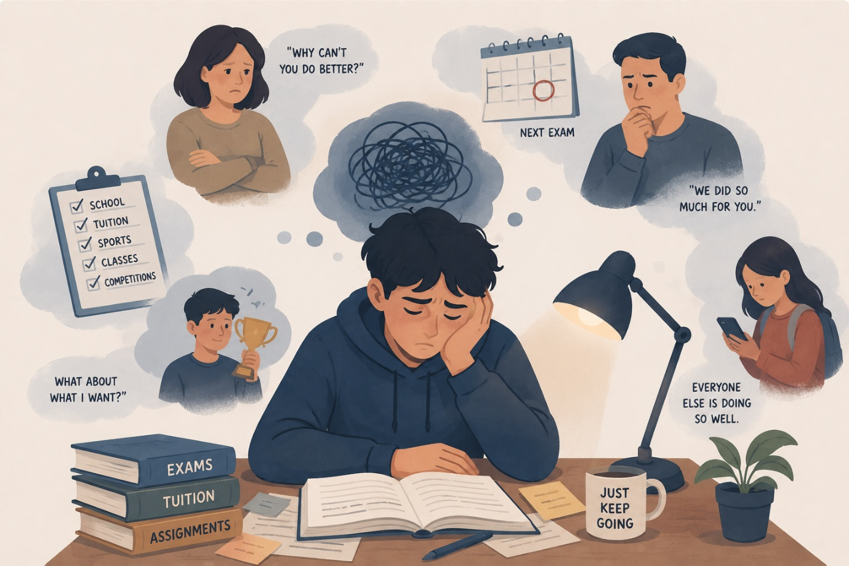
Is Your Teen Burned Out? The Warning Sign Most Parents Never Notice
Welcome back to the Ikigai Teen blog.
Imagine this: your teenager comes home from school, completes their assignments, attends tuition classes, and prepares for upcoming exams. They're not failing. They're not getting into trouble. In fact, they're doing everything they're supposed to do. Yet something feels different. The spark seems dimmer. The laughter comes less often. The curiosity that once filled conversations has quietly faded away. Most parents notice when a teenager starts struggling, but far fewer notice when a teenager starts merely surviving. And that is often where burnout begins.
The Myth We Need to Let Go Of
When we think about burnout, we tend to imagine dramatic moments—a student breaking down before an important exam, refusing to attend school, or openly admitting that they can no longer cope. The reality is often far less obvious. Burnout rarely arrives like a storm. Instead, it creeps in quietly, like a slow leak. There is a little less enthusiasm, a little less energy, and a little less joy each week. Over time, the teenager who once felt excited about life begins moving through it on autopilot.
The most difficult part is that the teenagers most vulnerable to burnout are often the ones we worry about the least. They continue meeting deadlines, attending classes, and checking every box placed before them. Because they keep going, we assume they are coping. Yet beneath that appearance of responsibility, many are carrying levels of pressure they have never learned how to express.
The Straight-A Student Who Stopped Dreaming
A counselor once shared the story of a student who consistently ranked among the top performers in her class. Her grades remained excellent, teachers praised her, and her parents admired her dedication. From the outside, everything looked perfect.
One day, however, someone asked her a simple question: "What are you excited about right now?"
She paused. Then she admitted she didn't know.
It wasn't because she lacked opportunities or talent. It was because she had spent so much time meeting expectations that she had lost touch with excitement itself. Somewhere along the way, achievement had replaced curiosity. Goals had replaced joy. What burnout often steals first is not performance—it is purpose.
Signs Burnout May Be Hiding Beneath the Surface
Many parents expect burnout to show up through poor grades or obvious emotional distress. Sometimes it does. More often, it reveals itself through subtle shifts in a teenager's relationship with learning and life.
A burned-out teen may never feel truly finished. No matter how much they accomplish, their attention immediately jumps to the next assignment, the next exam, or the next milestone. There is no sense of satisfaction—only the pressure of what comes next.
You may also notice that free time makes them uncomfortable. Instead of enjoying rest, they become restless. Productivity has become part of their identity, and slowing down feels almost wrong. They may even feel guilty when they are not being productive.
Another common sign is the loss of curiosity. Learning becomes something they do for grades rather than for growth. They stop asking questions simply because they are interested. Education becomes a transaction instead of an exploration.
Over time, conversations begin revolving around performance. Whether discussing academics, sports, or hobbies, they evaluate themselves through results. Their self-worth slowly becomes tied to achievements, rankings, and outcomes.
Small setbacks may start feeling unusually personal. A disappointing score is no longer viewed as feedback or an opportunity to improve. Instead, it feels like evidence that they are somehow not good enough.
Perhaps the most overlooked sign is the inability to enjoy success. Achievements bring relief rather than happiness. Instead of celebrating, they immediately focus on the next challenge ahead. The pressure doesn't disappear—it simply pauses for a moment.
Burned-out teens can also appear emotionally flat. They are not necessarily sad or angry; they simply seem disconnected. The highs feel less exciting, the lows feel numb, and life starts feeling more like a checklist than a journey.
Many begin living entirely in the future. Everything revolves around the next exam, the next competition, or the next stage of life. They become so focused on what's ahead that they stop experiencing the present moment.
When asked why they are working so hard, some teenagers struggle to answer. They know what they are doing, but they can no longer remember why they started. The original dream has been buried beneath years of expectations.
And sometimes, the clearest sign is that they seem older than they should. They become so disciplined, responsible, and focused on outcomes that they forget how to simply be teenagers. While responsibility is admirable, childhood and adolescence are not meant to be endured—they are meant to be lived.
What Burned-Out Teens Need Most
When parents notice these signs, the natural response is often to encourage more motivation. Yet motivation is rarely the missing ingredient. More often, what teenagers need is permission.
Permission to rest without guilt. Permission to make mistakes without fear. Permission to be valued for who they are rather than what they achieve.
Think of a tree that produces fruit year after year. Most people admire the fruit, but few pay attention to the roots. Yet healthy roots are what make future growth possible. Teenagers are no different. Before asking how much more they can achieve, we should ask whether they have enough emotional energy to keep growing.
A Different Question
This week, instead of asking your teenager, "How was your test?" try asking a different question:
"What has been taking up most of your energy lately?"
The answer may reveal far more than any report card ever could.
Final Thought
Burnout isn't always visible. Sometimes it hides behind good grades. Sometimes it hides behind responsibility. Sometimes it hides behind a smile.
Our teenagers do not need us to become managers of their performance. They need us to become students of their experience. When a young person feels seen beyond their achievements, something powerful begins to happen. They stop surviving and start thriving again.
In our next post, we'll explore an important question many families are asking: "How Can Teens Recover Their Motivation After Burnout?"
Until then, remember: a thriving teen is not the one who achieves the most. A thriving teen is the one who still has the energy, curiosity, and joy to become who they are meant to be.

